
FAST National University of Computer and Emerging Sciences
School of Management
Library Management System
Introduction to Database Systems
CS2013
Final Project
Phase 2

Submitted By:
Aleeha Waseem (24L-5735)
Hajira Tayyib (24L-5583)
Faria Imran (24L-5621)
Aila Zameer (24L-5650)

Submitted To:
Mr. Aqib Zeeshan

Date of Submission: 20/05/2026

Library Management System
System Overview:
This project outlines a centralized Library Management System designed to streamline the management of academic resources. By utilizing a relational SQL database, the system automates the tracking of book movements, manages member borrow limits, and provides real-time reporting for administrative decision-making.

- Data Flow Diagrams
Level 0 DFD – Context Diagram

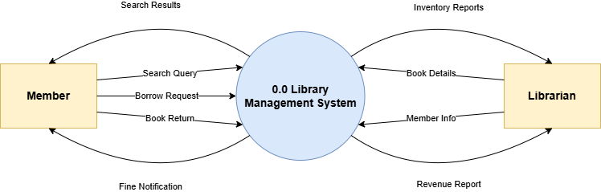
Fig 1:
Level 0 DFD-Context Diagram showing external entities and system boundaries.
The Context Diagram defines the boundary of the Library Management System. It illustrates the high-level interactions between the system and its external entities: the Librarian and the Member. The Librarian provides book and member data, while the system provides management reports. Members interact with the system to search for books, request issues/returns, and receive fine notifications.

- Data Flow Diagram
Level 1 DFD

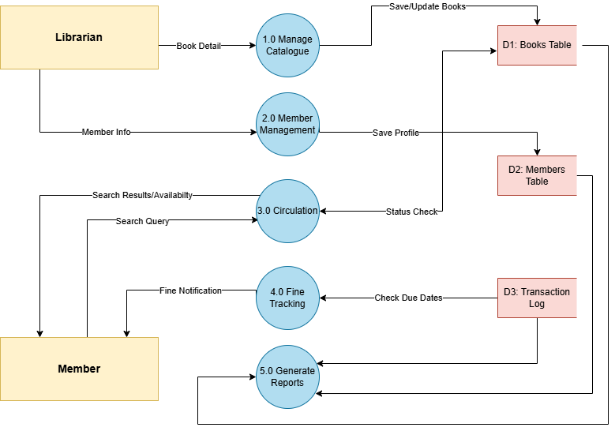
Figure 2:
Level 1 DFD showing the five core internal processes
The Level 1 DFD breaks down the system into five core functional processes: Cataloging, Member Management, Circulation, Fine Tracking, and Report Generation. This diagram shows how data flows between these processes and the three main data stores: Books, Members, and Transactions. It captures the automated logic of checking book availability and calculating penalties for late returns.

- Entity Relationship Diagram

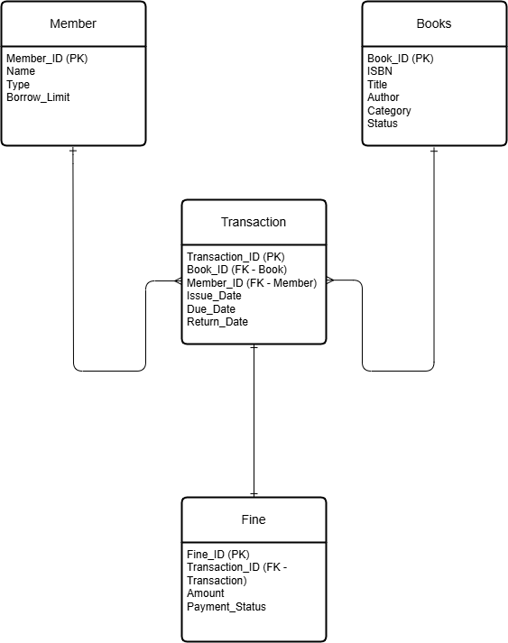
Figure 3:
Entity-Relationship Diagram illustrating the relational structure and key constraints.
The ERD represents the logical blueprint of the relational database. It identifies the four primary entities: Book, Member, Transaction, and Fine. The diagram uses Crow’s Foot notation to show relationships, such as the 1-to-Many (1:N) relationship between a Member and their Transactions. Primary Keys (PK) and Foreign Keys (FK) are established to ensure data integrity and prevent redundancy.
- Detailed Relational Schema
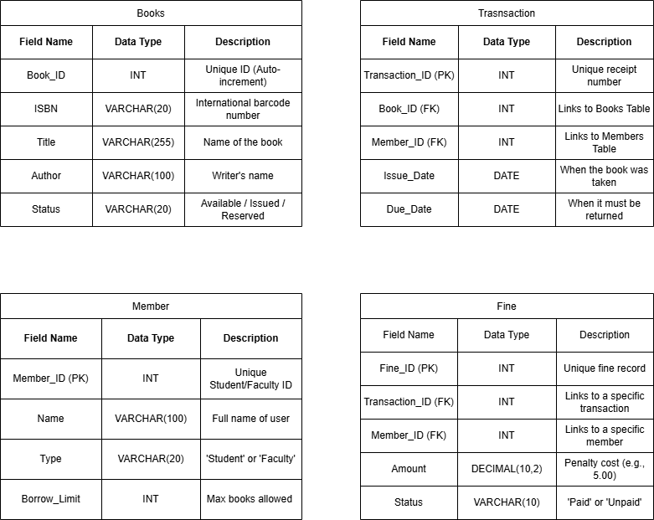
Figure 4:
Detailed Relational Schema with data types and primary/foreign keys.
The Relational Schema defines the physical structure of the database tables. It specifies the technical attributes for every field, including Data Types (such as INT for IDs and VARCHAR for text) and constraints. This schema ensures that the SQL implementation is optimized for performance, specifically regarding the linking of book metadata to transaction logs and the calculation of fine amounts.

